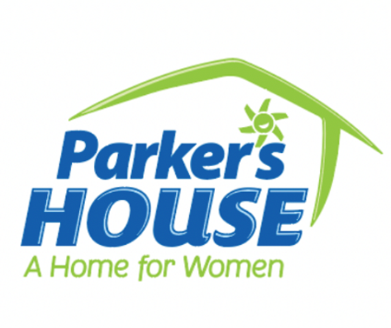

**NEWS RELEASE**

**FOR IMMEDIATE RELEASE**

**Media Contact:**

**Allison Hersh**

**Capricorn Communications**

**912.441.1285 |** [**pr@capricorncomm.com**](mailto:pr@capricorncomm.com)

**Union Mission, Parker’s Host Ribbon Cutting for Parker’s House, the Only Facility Dedicated Solely to**

**Unaccompanied Homeless Women in Savannah, Ga. and Across Coastal Georgia**

**SAVANNAH, Ga. (Sept. 1, 2022)** – [Union Mission](http://www.unionmission.org/) and[Parker’s](http://www.parkerskitchen.com/) hosted a Ribbon Cutting Ceremony on Aug. 31 for the new **Parker’s House: A Home for Women**, which will be the only facility solely dedicated to providing emergency housing and comprehensive services for unaccompanied women experiencing homelessness in Savannah, Ga. and across coastal Georgia. Parker’s House will officially open to women in need on Tuesday, September 6 and will provide housing and support services to 100 women annually.

Featured speakers at the Parker’s House Ribbon Cutting Ceremony included Savannah Mayor Van Johnson, Union Mission President and CEO Michael Traynor, Parker’s Founder and CEO Greg Parker, Union Mission Board Chairman Neilie Dunn, Sarah Mills Hodge Foundation Board Chairman Dr. Paul Pressly and Reverend Patricia Youngquist.

“On any given night in Chatham County, approximately 180 women are experiencing homelessness,” said Union Mission President and CEO Michael Traynor. “The demand for Parker’s House from women in our community is tremendous. This facility will be laser-focused on helping unaccompanied, homeless women, offering much-needed housing and essential services 24/7.”

Located at 125 Fahm St. in the former J.C. Lewis Healthcare building in Savannah, the 10,590-square-foot facility will offer emergency housing, on-site case workers, residential assistants and support services for up to 32 women for 90 days. Parker’s House also includes a common kitchen, living room, dining room, computer room, multi-purpose conference center and laundry room. Interior walls throughout the facility feature empowering quotes designed to inspire women at Parker’s House.

“It’s not a crime to be homeless,” Savannah Mayor Van Johnson told the audience in attendance at the ribbon cutting. “It’s a crime not to do something about it.”

In 2021, Parker’s made a $250,000 donation to Union Mission from the Parker’s Community Fund, which is administered by the Savannah Community Foundation, to support the founding of the new Parker’s House. The Parker’s Community Fund is focused on making a transformative impact in the areas that Parker’s serves in Georgia and South Carolina.

“We’re thrilled to support Union Mission’s vision to create a safe space for women experiencing homelessness in Savannah by creating Parker’s House,” said Parker’s founder and CEO Greg Parker. “There’s an urgent need to provide emergency housing and support services for women in need right here in our community.”

At the ribbon cutting, Parker issued a challenge to the Savannah community, pledging to match up to $100,000 for new donations made to Parker’s House through September 30, 2022.

In addition, SCAD SERVE -- a university initiative devoted to developing meaningful community-related solutions -- commissioned Savannah College of Art and Design graduate Robin Maaya (B.F.A., photography, 2021) to work with Union Mission to beautify the walls at Parker’s House by photographing Union Mission clients in various programs. The collection of 28 photographs entitled “Mission of Mercy” portrays the stories and celebrates the lives of local men and women served by Union Mission.

Parker’s House offers a safe, secure environment that includes 16 bedrooms with shared baths for unaccompanied women experiencing homelessness as well as an adjacent gated courtyard that was renovated by accomplished local landscape designer John McEllen. Interior renovations included building out the existing space to comply with COVID-19 safety standards and precautions, upgrades to ensure American Disabilities Act compliance as well as improvements to the electrical, plumbing and fire suppression systems.

Each Parker’s House client will be assigned a case manager for Individualized Case Management, wellness checks, employment support and referrals to primary care and mental health providers. For clients in mental health crisis, the Union Mission Counseling Center will create Individual Service Plans.

Women comprise approximately 28% of the homeless population in Savannah. Savannah-Chatham County has the second highest rate of homelessness in Georgia.

In 2021, Union Mission helped transition 603 men, women and children from the streets of Savannah to safe, stable housing, providing 134,658 nights of housing and more than 75,320 meals to individuals and families in need.

**ABOUT UNION MISSION:**

[Union Mission](https://www.unionmission.org/) has cared for Savannah’s homeless community for 85 years, offering emergency, transitional and permanent housing solutions to those in need. Union Mission also provides mental health counseling, food, clothing, transportation and job placements as part of its comprehensive wrap-around supportive services available to all homeless people in the community. The mission of Union Mission is: *to partner with people to end their homelessness through housing and supportive services*. Learn more: [**www.unionmission.org**](http://www.unionmission.org/). 

**ABOUT PARKER’S:**

Honored as the 2020 *Convenience Store Decisions* Chain of the Year, [Parker’s](http://parkerskitchen.com/) is strategically redefining the nation’s convenience store industry, offering customers high-quality products, freshly prepared food and superior customer service at retail stores throughout southeast Georgia and South Carolina. Headquartered in Savannah, Ga., Parker’s has a commitment to exceeding customer expectations and has repeatedly been recognized as one of the nation’s leading convenience store and foodservice companies. Parker’s Kitchen, the popular food-centric brand under the Parker’s umbrella, serves world-famous hand-breaded Southern Fried Chicken Tenders as well as made-from-scratch mac ‘n’ cheese, a breakfast bar and daily specials. The company’s popular Parker’s Rewards loyalty program, which includes more than 300,000 members, has saved Parker’s customers more than $15 million to date. Learn more: [**www.parkerskitchen.com**](http://www.parkerskitchen.com/)**.**

**ABOUT THE PARKER’S COMMUNITY FUND:**

Since January 2021, Parker’s has donated more than $22 million to the Parker’s Community Fund, which is administered by the Savannah Community Foundation, to support charitable initiatives throughout the company’s corporate footprint in coastal Georgia and South Carolina. A Community Impact Committee makes strategic decisions about how to allocate the funds in order to make the biggest impact. An important part of the company’s ongoing commitment to charitable giving, the Parker’s Community Fund amplifies the impact of the Parker’s Fueling the Community initiative as well as landmark gifts to name the Parker College of Business at Georgia Southern University and the Parker’s Emergency and Trauma Center at Memorial Hospital in Savannah, Ga. Learn more: [**www.parkerskitchen.com/parkers-community-fund**](http://www.parkerskitchen.com/parkers-community-fund)

###

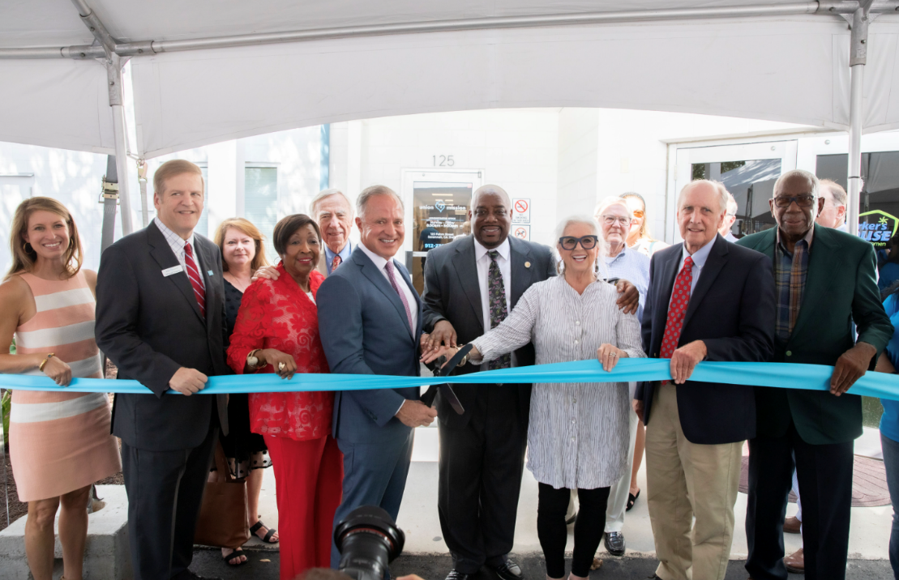

**PHOTO CAPTION: Union Mission and Parker's hosted a Ribbon Cutting Ceremony on Aug. 31 for Parker’s House, which will be the only facility solely dedicated to providing emergency housing and comprehensive services for unaccompanied women experiencing homelessness in Savannah, Ga. and across coastal Georgia. Parker's Founder and CEO Greg Parker, center, cut the ribbon, surrounded by Union Mission Board Chair Neilie Dunn, Union Mission President and CEO Michael Traynor, former Savannah Mayor Edna Jackson, Savannah Mayor Van Johnson, Paula Deen, Dr. Paul Pressly and District 3 County Commissioner Bobby Lockett (front row, l-r).**

**NOTE TO MEDIA: Please click** [**HERE**](https://www.dropbox.com/scl/fo/z0eiif3slx61qar06dv29/h?dl=0&rlkey=kizt5ntp6aho46luhe43b0514%20) **to download high-res Parker's House photos.**